DealersAutoCenter Task2
Task2: Payment Service:
1)Overview
This Spring Boot API simulates the dealer subscription payment processing workflow. It provides an endpoint to initiate a payment for a dealer subscription, saves the payment with an initial status of PENDING, and automatically updates the payment status to SUCCESS after a delay of 5 seconds — simulating an external payment gateway callback.
The API supports multiple payment methods: UPI, Card, and NetBanking. Additionally, the API is secured using JWT-based authentication.
2)Entities (Auto generated using JPA):
Column | Type | Description
payment_id | BIGSERIAL | Primary key (auto-generated)
dealer_id | BIGINT | Foreign key referencing the dealer
amount | DOUBLE | Amount paid
date_time | TIMESTAMP | Timestamp of payment creation
payment_method | VARCHAR(20) | Payment method (UPI, Card, NetBanking)

3)API endpoints:

Authentication (default user=user ,password=pass):
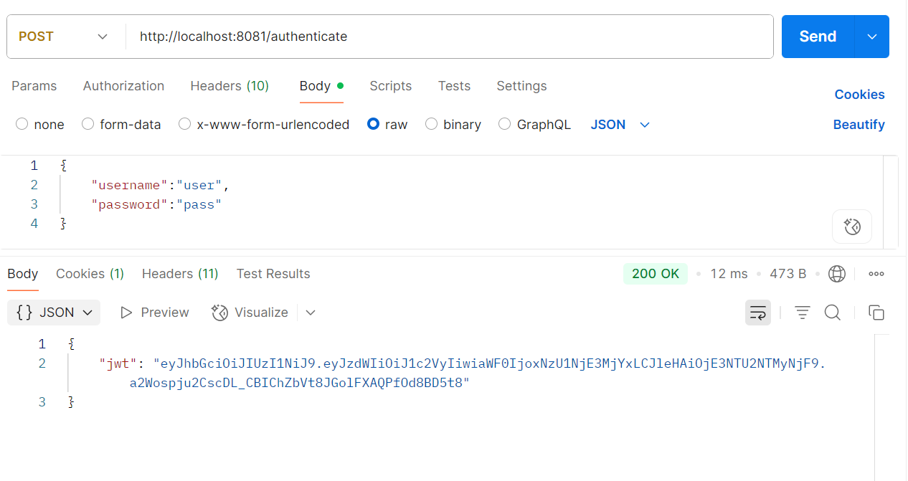
Payment(pass token generated in above API as Authorisation Header):
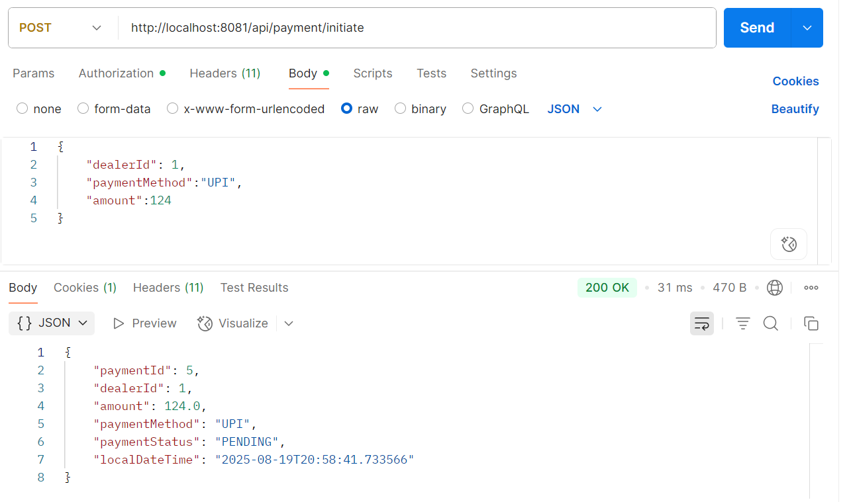
4)Deployment link : https://github.com/brajeshBrajesh/dealersautocenterTask/tree/payment_service

5)How to run
1) Pre-requisites: Configure postgres in port : 5432 and made database with name = dealerdb
2)Clone repository from github repo provided in step 4 and run spring boot application. This will run application on port:8081
3)Import paymentService.json file in Postman. This will postman collection.
4)First hit /authenticate API with default user and password(user=user,password=pass) .This will return JWT token.
5)Hit /api/payment/initiate API. Pass token generated in step 4 as Bearer token

6) Attachments on email
- paymentService.json to be imported on postmen.
- PaymentService-0.0.1-SNAPSHOT.jar file :Can be run directly

